
Blundell’s School Shop
Tiverton
Devon
EX16 4DR
01884 232316
shop@blundells.org

Name Tape Order Form

If you would like to order name tapes through us, please complete the form below and email it to shop@blundells.org or drop it into the School Shop.

The name tapes will be delivered to the School Shop and we will let you know when they are ready to collect. Payment can be made at collection or added to your Blundell’s School account.

All items of clothing must be clearly marked on the inside of each garment with the pupil’s name and House. If your child is a boarder, please ensure all home clothing is also named.

Woven Name Tapes

Style 1 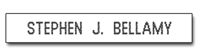 | Style 2  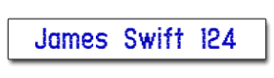 | Style 3  
Style 4  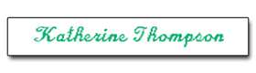 | Style 5  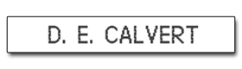 | Style 6  

NAME REQUIRED & HOUSE INITIALS (please print clearly)

E.g. Jack Hughes P.G. ……………………………………………………………………………………….

Style of lettering |  | Green  lettering | Black  lettering | Blue  lettering | Red  lettering |  | 72 name tapes  (£10) | 144 name tapes  (£15)

PARENT/GUARDIAN NAME …………………………………………… DATE ………………………

SIGNED ………………………………………….. CONTACT NUMBER ……………………………….

